

ENDURO_RR_390_4T_MY22
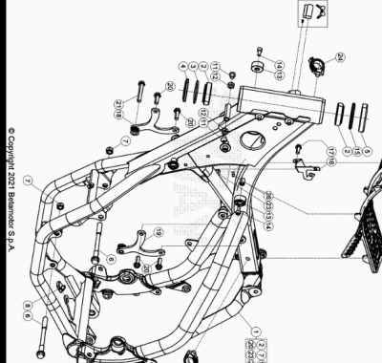

ENDURO_RR_390_4T_MY22
Ref. | Part Number | Description | Part
1 | 037.31.058.80.50 | CHASIS RR 4T MY 20 | 1
2 | 12.99510.000 | COJINETE CÓNICO 29X50X15 RR-4T | 2
3 | 10.66935.000 | JUNTA TÓRICA RR-4T | 1
4 | 020.31.039.00.00 | GUARDAPOLVO DIRECCION | 1
5 | 031.31.016.22.00 | PROTECCION COJINETE | 1
6 | 11.64607.000 | TORNILLO ESPECIAL RR-4T | 2
7 | 13.21060.000 | TUERCA AMBRIDADA M10 X 1,25 | 2
8 | 25.60311.000 | GRAPA TORNILLO M6 ALP 4.0 2008 | 1
9 | 037.31.024.00.00 | CERRADURA BLOCAJE | 1
10 | 037.31.071.00.59 | GOMA PROTECTOR DEPOSITO | 1
11 | 31.64060.000 | TORNILLO TBIB 8.16 | 2
12 | 13.16000.000 | TUERCA 8.6 CH13 | 2
13 | 29.10310.000 | TOPE GOMA DEPOSITO TR-34/RR-4T | 2
14 | 31.31050.000 | TORNILLO ALLEN TCCE 6.15 | 2
15 | 031.32.007.00.00 | ANILLO DE SELLADO | 1
16 | 037.40.069.22.00 | SOPORTE INSTALACION | 1
17 | 11.48025.000 | TORNILLO HEX/C.ARO 6x16 ( RS-T.8 ) | 1
18 | 037.32.006.80.00 | ANCLAJE MOTOR | 1
19 | 037.32.007.50.00 | ANCLAJE MOTOR | 1
20 | 11.54521.000 | TORNILLO 8.16 RS C/ARANDELA CH.10 | 4
21 | C24.31.045.00.00 | TORNILLO 8 X 65 | 1
23 | 27.33741.000 | REMACHE | 1
24 | 25.24444.000 | PASA CABLE DIÁMETRO 19 RR-4T | 1
25 | 25.24440.000 | GUIA CABLES CHASIS SCOOTER | 1
26 | 25.24443.000 | GUIA CABLE 6/6 RR-4T / RR 125 / RR-T | 1

ENDURO_RR_390_4T_MY22
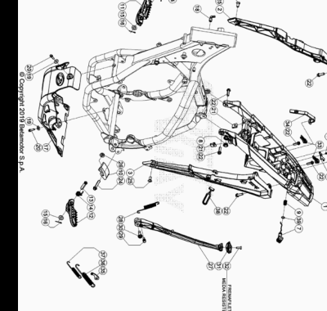

ENDURO_RR_390_4T_MY22
Ref. | Part Number | Description | Part
1 | 040.32.035.80.59 | CHASIS POSTERIOR | 1
2 | 037.32.033.87.59 | SOPORTE SUBCHASIS | 1
3 | 037.32.034.87.59 | SOPORTE COLA TRASERA | 1
4 | 020.32.010.00.05 | CHAPA FIJ. CERRADURA | 1
5 | 020.32.112.00.00 | EJE CERRADURA | 1
6 | 037.32.013.50.00 | SOPORTE | 1
7 | 037.32.014.87.59 | PULSANTE ASIENTO | 1
8 | 037.38.003.00.00 | SOPORTE | 1
9 | 020.32.016.00.00 | MUELLE | 1
10 | 25.25601.000 | PATIN TENSOR RR 4T 2008 | 1
11 | 037.32.009.00.00 | ESTRIBERA DX | 1
12 | 037.32.008.00.00 | ESTRIBERA SX | 1
13 | 25.54465.000 | EJE ESTRIBERA RR-4T | 2
14 | 037.32.019.00.00 | MUELLE | 2
15 | 031.32.001.00.00 | ARANDELA 10 X 21 X 2 | 2
16 | 12.81993.000 | PASADOR EJE ESTRIBERA | 2
17 | 037.32.018.00.59 | PROTECTOR MOTOR | 1
18 | 27.23470.000 | RACORD MOTOR RK6-50/ TUBO GASOLINA RR-T/ART - RR-4T- RR 125 | 1
19 | 27.42000.000 | ARANDELA PLANA 6.18 | 2
20 | 11.49070.000 | TORNILLO 6X20 RS CH8 | 2
21 | 25.60311.000 | GRAPA TORNILLO M6 ALP 4.0 2008 | 2
22 | 31.64070.000 | TORNILLO ESPECIAL 8X25 CH10 | 6
23 | 31.29810.000 | TORNILLO TBCE 5.12 | 2
24 | 11.55480.000 | TORNILLO 8.40 PF C/ARANDELA | 1
25 | 007.32.032.00.00 | TORNILLO ESP. TSBEI CH6 M8X20 10.9 ZINC | 2
26 | 13.17120.000 | TUERCA M8 BASE CILINDRO | 1
27 | 037.32.010.82.00 | KIT CABALLETE | 1
28 | 037.32.030.00.00 | MUELLE | 1
29 | 11.66615.000 | TORNILLO ESP. CAVALLETE RR 4T 2008 | 1
30 | 11.66614.000 | TORNILLO ESPECIAL CABALLETE RR 4T 2008 | 1
31 | 037.32.017.00.00 | SOPORTE | 1
32 | 31.34400.000 | TORNILLO 6 X 20 | 1
33 | 037.32.027.00.00 | KIT TAPON | 1
34 | 037.43.043.00.00 | GOMA BATERIA | 1
35 | 037.32.031.50.00 | SOPORTE MUELLE CABALLETE | 1
36 | 037.32.029.00.00 | MUELLE | 1
37 | 037.32.028.00.00 | MUELLE | 1
38 | 16.34907.000 | GOMA CABALLETE RR-4T | 1
39 | C02.06.066.00.00 | RETEN 9.52 X 1.78 | 1

ENDURO_RR_390_4T_MY22
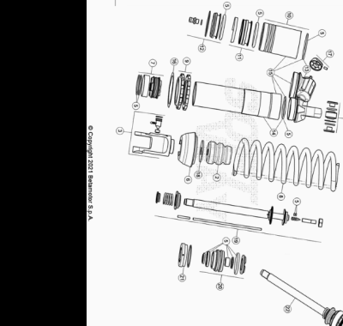

ENDURO_RR_390_4T_MY22
Ref. | Part Number | Description | Part
1 | 037.33.020.80.00 | AMORTIGUADOR RR 4T | 1
2 | 037.33.009.00.00 | TAPON AMORTIGUADOR | 1
3 | 037.33.010.00.00 | HORQUILLA AMORTIGUADOR | 1
4 | 13.86078.800 | KIT DISTANCIADOR AMORTIGUADOR RRT-4T-GR | 1
5 | 037.33.011.82.00 | KIT JUNTAS | 1
6 | 037.33.012.00.00 | TAPON AMORTIGUADOR | 1
7 | 026.33.020.00.00 | PISTON | 1
8 | 037.33.022.00.00 | MUELLE | 1
9 | 026.33.019.00.00 | TUERCAS AMORTIGUADOR | 1
10 | 026.33.012.00.00 | DEPOSITO AMORTIGUADOR | 1
11 | 026.33.013.00.00 | MEMBRANA | 1
12 | 026.33.014.00.00 | TAPON | 1
13 | 037.33.013.00.00 | TAPON | 1
14 | 037.33.014.00.00 | CUERPO AMORTIGUADOR | 1
15 | 037.33.015.00.00 | CUERPO AMORTIGUADOR | 1
16 | 031.33.012.00.00 | ARANDELA | 1
17 | 026.33.021.00.00 | TAPON REGISTRO | 1
18 | 031.33.014.00.00 | ARANDELA | 1
19 | 037.33.016.00.00 | VARILLA | 1
20 | 037.33.017.00.00 | GUIA | 1
21 | 026.33.026.00.00 | TAPON | 1
22 | 037.33.023.80.00 | VARILLA COMPLETA | 1

ENDURO_RR_390_4T_MY22
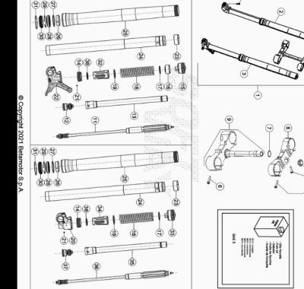

ENDURO_RR_390_4T_MY22
Ref. | Part Number | Description | Part
1 | 037.34.070.80.00 | HORQUILLA COMPLETA RR 4T | 1
2 | 037.34.064.80.00 | BRAZO DX HORQUILLA RR 4T | 1
3 | 037.34.065.80.00 | BRAZO SX HORQUILLA RR 4T | 1
4 | 020.34.004.00.00 | TUERCA M 20 X 1,5 HORQUILLA RR 4T MY 10 | 1
5 | 11.55440.000 | TORNILLO C/HEX. 10 M8x30 DIN 933 8.8 | 1
6 | 11.55510.000 | TORNILLO 8.40 ALP 200/08 | 8
7 | 10.66420.000 | ANILLO OR 22-3,53 NBR | 1
8 | 037.34.001.42.59 | PLETINA SUPERIOR HORQUILLA | 1
9 | 037.34.002.80.59 | PLETINA HORQUILLA | 1
10 | 031.34.072.00.00 | TORNILLO M 8.25 8.8 | 4
11 | 037.34.066.00.00 | GRUPO EXTENSION | 1
12 | 037.34.067.00.00 | GRUPO COMPRESION | 1
13 | 037.34.015.00.00 | TUBO | 1
14 | 020.34.313.00.00 | ANILLO DE APOYO VARILLA+ O.RING | 2
15 | 040.34.050.00.00 | TAPON HORQUILLA | 1
16 | 037.34.011.00.00 | DISTANCIADOR | 1
17 | 031.34.323.00.00 | ARANDELA | 2
18 | 031.34.025.00.00 | MUELLE K=4,8 N/MM | 2
19 | 040.34.041.00.00 | ARANDELA | 2
20 | 037.34.014.00.00 | PIE HORQUILLA | 1
21 | 020.34.308.00.00 | CLAVIJA | 2
22 | 037.34.013.00.00 | PIE HORQUILLA | 1
23 | 020.34.320.00.00 | CASQUILLO 049/47 L 20 | 2
24 | 031.34.021.00.00 | BARRA HORQ,. RR 2T/4T | 2
25 | 040.34.040.00.00 | BOTELLA HORQUILLA RR 2T | 2
26 | 031.34.020.00.00 | DISTANCIADOR D.52/48 L12 | 2
27 | 020.34.318.00.00 | DISTANCIADOR | 2
28 | 020.34.317.00.00 | RETEN HORQUILLA 48X58X9/11,5 | 2
29 | 020.34.316.00.00 | SEEGER 58,45 | 2
30 | 020.34.315.00.00 | GUARDAPOLVO HORQUILLA | 2
31 | 026.34.364.00.00 | ANILLO BLOQUEO | 2
32 | 040.34.042.00.00 | GUIA MUELLE | 1
33 | 040.34.051.00.00 | TAPON HORQUILLA | 1
34 | 040.34.043.00.00 | GUIA MUELLE | 1
35 | 037.34.016.00.00 | TUBO | 1
36 | 037.34.068.00.00 | GRUPO EXTENSION | 1
37 | 037.34.069.00.00 | GRUPO COMPRESION | 1
38 | 040.34.044.00.00 | ARANDELA | 2

ENDURO_RR_390_4T_MY22
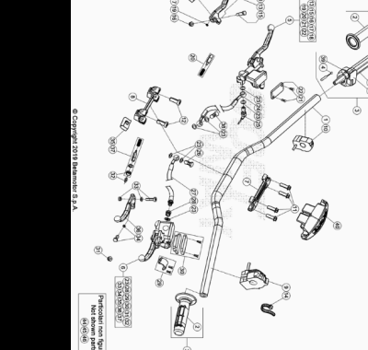

ENDURO_RR_390_4T_MY22
Ref. | Part Number | Description | Part
1 | 037.35.000.00.59 | MANILLAR | 1
2 | 036.35.005.00.00 | JUEGO DE PUÑOS ENDURO | 1
3 | 037.35.001.80.00 | MANDO GAS CON PUÑOS RR 4T | 1
4 | 037.35.004.82.00 | CABLE GAS | 1
5 | 21.02057.059 | BOMBA FRENO DELANTERA RR4T RACING | 1
6 | 020.35.120.82.00 | #020.35.020.00.00# | 1
7 | 12.08253.000 | ABRAZADERA SUPERIOR HORQUILLA RR-4T | 1
8 | 12.08263.000 | ABRAZADERA INF HORQUILLA RR4T 1508050 | 1
9 | 016.35.010.00.00 | MANDO LUCES CON INTERMITENTES ENDURO 2017 | 1
10 | 026.40.047.00.00 | DISPOSITIVO ON/OFF | 1
11 | 31.64070.000 | TORNILLO ESPECIAL 8X25 CH10 | 4
12 | 31.65626.000 | TORNILLO 10X25 RR-4T | 2
13 | 21.27104.000 | MANETA FRENO ANT. FORJADA RR 4T | 1
14 | 15.14264.000 | ABRAZ.PA 6 NY.DENT.NAT.ABNY-B 3,6 X 200 | 1
15 | 31.96832.000 | PASADOR MANETA FRENO | 1
16 | 13.30911.000 | TUERCA PASADOR MANETA FRENO | 1
17 | 16.33841.000 | GOMA RR 4T 2008 | 1
18 | 31.88604.000 | TORINILLO REG | 1
19 | 22.38704.000 | MUELLE REG. BOMBA FRENO | 1
20 | 20.08258.000 | JUEGO PISTON COMPL. BOMBA FRENO ANT. RR-4T | 1
21 | 31.23410.052 | TORNILLO TAPA DEP. LIQUIDO FRENOS | 2
22 | 031.36.003.82.00 | KIT TAPA BOMBA FRENO ANT. RR2T | 1
23 | 16.50510.000 | JUNTA 10.15.1 (COBRE) | 7
24 | 037.36.002.00.00 | TUBO FRENO | 1
25 | 18.89621.000 | INTERRUPTOR STOP RR-4T | 1
26 | 11.65040.000 | TORNILLO ESP. TALAD.10.1 PARA TUBO FRENO | 1
27 | 037.35.003.00.00 | TUBO EMBRAGUE | 1
28 | 020.35.032.00.00 | RACORD BOMBA EMBRAGUE | 1
29 | 020.35.025.00.00 | BRIDA | 1
30 | 020.35.023.00.00 | TAPA DEPOSITO BOMBA EMBRAGUE | 1
31 | 020.35.028.00.00 | ANTIEMULSION | 1
32 | 020.35.029.00.00 | VARILLA DE PRESION | 1
33 | 020.35.024.00.00 | EJE PALANCA | 1
34 | 020.35.030.00.00 | GUIA RESORTE | 1
35 | 020.35.027.00.00 | GOMA PROTECCION PALANCA | 1
36 | 020.35.022.00.00 | MANETA EMBRAGUE RR4T 2012 | 1
37 | 020.35.026.00.00 | KIT PISTON BOMBA | 1
38 | 11.65053.000 | TORNILLO ESPECIAL TALAD.10..1,25 RR-4T | 1
39 | 031.35.013.00.00 | PROTECCION | 1
40 | 037.43.016.00.59 | PROTECCION MANILLAR | 1
42 | 008.35.003.00.00 | TAPA | 1
44 | 12.30100.000 | SOPORTE MANETA FRENO ANT (ESPEJO) | 1
45 | 28.92927.000 | #28.92927.800# | 1
46 | 031.35.008.00.00 | RETROVISOR SX | 1
47 | 031.35.014.00.00 | CAÑA MANDO GAS RR 4T | 1

ENDURO_RR_390_4T_MY22
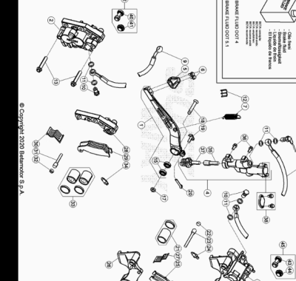

ENDURO_RR_390_4T_MY22
Ref. | Part Number | Description | Part
1 | 037.36.004.80.00 | PEDAL FRENO | 1
2 | 25.03056.000 | PINZA FRENO ANTERIOR RR-4T | 1
3 | 25.03066.000 | PINZA FRENO POSTERIOR RR-4T | 1
4 | 25.91178.000 | BOMBA FRENO POSTERIOR ENDURO RR 4T /07 | 1
5 | 22.90053.000 | PUNTERA PEDAL FRENO RR-4T | 1
6 | 11.46251.000 | TORNILLO 5.12 RS CH8 | 2
7 | 037.36.003.00.00 | MUELLE | 1
8 | 29.09428.000 | TUBO FRENO POSTERIOR ENDURO RR 4T /07 | 1
9 | 037.36.002.00.00 | TUBO FRENO | 1
10 | 11.65053.000 | TORNILLO ESPECIAL TALAD.10..1,25 RR-4T | 2
11 | 16.50510.000 | JUNTA 10.15.1 (COBRE) | 6
12 | 25.24442.000 | GUIA CABLE 6/8 RR-4T / RR 125 / RR-T | 1
13 | 11.55510.000 | TORNILLO 8.40 ALP 200/08 | 2
14 | 18.89621.000 | INTERRUPTOR STOP RR-4T | 1
15 | C06.01.047.00.00 |  | 2
17 | 13.21060.000 | TUERCA AMBRIDADA M10 X 1,25 | 1
18 | 037.36.001.00.00 | TORNILLO ESPECIAL M. 10 X 1,25 X 35 | 1
19 | 25.41830.000 | EJE BOMBA POST.RR-4T/07 | 1
20 | 12.81995.000 | PASADOR 2.15 INOX REV 3 | 1
21 | 20.02717.000 | JUEGO PISTON Y GUARNICIÓN PINZA RR-4T | 1
22 | 31.96821.000 | TORNILLO ESP. PASTILLAS PINZAS RR-4T/06 | 1
23 | 25.41860.000 | VARILLA ESP. PASTILLAS PINZAS RR-4T/06 | 1
24 | 28.91002.000 | AIREADOR PINZAS FRENO RR-4T | 1
25 | 25.25362.000 | JUG. PASTILLAS PINZA FRENO POSTERIOR RR-4T | 1
26 | 020.36.011.00.00 | BRIDA SOPORTE PINZA | 1
27 | 22.32208.000 | MUELLE PASTILLAS PINZA RR-4T | 1
28 | 020.36.012.00.00 | BRIDA SOPORTE PINZA ANT. 25.03056. 0.00 | 1
29 | 25.25365.000 | JUG.PASTILLAS FRENO ANT. TT2701HH- RR4T | 1
30 | 22.32207.000 | MUELLE PASTILLAS PINZA RR-4T | 1
31 | 25.41859.000 | VARILLA ESP. PASTILLAS PINZAS RR-4T/06 | 1
32 | 31.96821.000 | TORNILLO ESP. PASTILLAS PINZAS RR-4T/06 | 1
33 | 20.02716.000 | JUEGO PISTON Y GUARNICIÓN PINZA RR-4T | 1
34 | 28.91001.000 | AIREADOR PASTILLAS PINZA RR-4T | 1
35 | 20.08276.000 | JUEGO PISTON BOMBA FRENO RR 4T 2008 | 1
36 | 31.30750.000 | TORNILLO TBIB 6.16 | 2
37 | 20.08277.000 | KIT LEVA BOMBA FRENO | 1
38 | 20.08275.000 | KIT DEPOSITO BOMBA RR 4T 2008 | 1
40 | 036.36.002.00.00 | PROTECCION | 1
41 | 036.36.003.00.00 | PROTECCION | 1
42 | 036.36.006.82.00 | PROTECCION ANTERIOR | 1
43 | 036.36.004.00.00 | PROTECCION | 1
44 | 036.36.005.00.00 | PROTECCION | 1
45 | 036.36.007.82.00 | PROTECCION POSTERIOR | 1

ENDURO_RR_390_4T_MY22
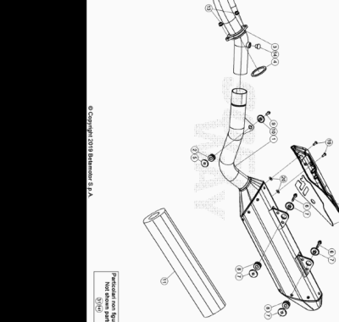

ENDURO_RR_390_4T_MY22
Ref. | Part Number | Description | Part
1 | 037.37.000.80.00 | SILENCIOSO RR 4T | 1
2 | 007.37.035.00.00 | SILENT BLOCK | 1
3 | 037.37.008.00.00 | COLECTOR RR 4T | 1
4 | 020.37.004.00.00 | JUNTA COLECTOR ESCAPE | 1
5 | 007.37.037.00.00 | ARANDELA ROSCA SILENT BLOCK | 1
6 | 11.50300.000 | TORNILLO 6,30 RS CH 8 RR-4T / RR 125 | 2
7 | 026.37.006.00.00 | DISTANCIADOR ESCAPE | 4
8 | 032.37.013.00.00 | SILENT-BLOCK | 2
9 | 11.49070.000 | TORNILLO 6X20 RS CH8 | 1
10 | 037.37.021.00.00 | DISTANCIADOR | 1
11 | 031.45.108.82.00 | KIT SILENCIOSO | 1
13 | 13.17121.000 | TUERCA M8 BASE CILINDRO CH.10 | 2
14 | 031.37.030.00.00 | TAPON SENSOR OXIGENO | 1
17 | 037.37.009.85.59 | PROTECTOR SILENCIOSO | 1
18 | 037.37.010.00.00 | PROTECTOR CALORICO | 1
19 | 31.29810.000 | TORNILLO TBCE 5.12 | 2
20 | 16.47491.000 | JUNTA PROT. TUBO ESCAPE | 2
31 | 037.37.002.00.00 | COLECTOR ESCAPE | 1
141 | 037.13.009.00.00 | SENSOR | 1

ENDURO_RR_390_4T_MY22
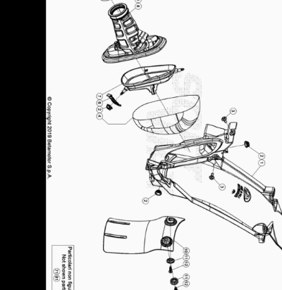

ENDURO_RR_390_4T_MY22
Ref. | Part Number | Description | Part
1 | 037.38.000.87.59 | CAJA FILTRO | 1
2 | 037.38.003.00.00 | SOPORTE | 3
3 | 037.43.029.00.00 | TORNILLO ESP. M 6 X 12 | 2
4 | 037.38.002.82.00 | FILTRO AIRE RR 2T/4T 2020/21 | 1
6 | 037.38.006.00.59 | SOPORTE CAJE FILTRO | 1
7 | 037.38.001.87.00 | JAULA FILTRO AIRE | 1
8 | 037.38.004.00.00 | MANGUITO CAJA FILTRO | 1
9 | 15.14606.000 | BRIDA CARBURADOR RR-4T | 1
10 | 026.38.007.10.59 | PROTECTOR AMORTIGUADOR | 1
11 | 27.74786.000 | ARANDELA RR-4T | 2
12 | 31.30815.000 | TORNILLO AUTOROSC. 6 X 20 | 2
71 | 037.38.008.00.00 | JAULA | 1
81 | 037.38.005.00.00 | MANGUITO CAJA FILTRO EU | 1

ENDURO_RR_390_4T_MY22
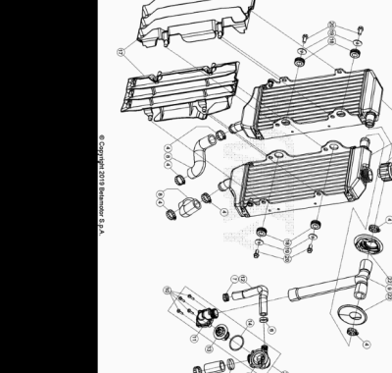

ENDURO_RR_390_4T_MY22
Ref. | Part Number | Description | Part
1 | 037.39.027.00.00 | RADIADOR RR 4T | 1
2 | 037.39.028.00.00 | RADIADOR RR 4T | 1
3 | 037.39.021.00.00 | TAPON RADIADOR RR 4T | 1
4 | 15.15240.000 | BRIDA 17/29 VELOXBLOC 3B | 7
5 | C07.16.005.00.00 | ABRAZADERA D.25 | 1
6 | 020.39.009.00.00 | ABRAZADERA 17 | 1
7 | 15.15220.000 | BRIDA 12/20 APA SX9-C-W1 | 1
8 | 037.39.013.00.00 | TUBO RADIADOR RR 4T | 2
9 | 037.39.009.00.00 | TUBO TERMOSTATO RR 4T | 1
10 | 031.39.017.50.00 | TORNILLO ESPECIAL M 3, 5X18 | 4
11 | 037.39.006.00.00 | CONTENEDOR TERMOSTATO | 1
12 | 037.39.012.00.00 | TUBO TERMOSTATO RR 4T | 1
13 | 020.39.013.00.00 | TERMOSTATO | 1
14 | 10.66830.000 | TORICA OR 32X2 REV4T | 1
16 | 040.39.000.00.00 | TUBO AGUA | 1
17 | 037.39.003.00.51 | REJILLAS RADIADOR *JUEGO* | 1
18 | 035.39.006.00.00 | SILENT BLOCK | 4
19 | 27.43250.000 | ARANDELA PLANA 6.24 | 4
20 | 11.47015.000 | TORNILLO 6.12 REV3-04 - RR-4T | 4
21 | 037.39.006.80.00 | TERMOSTATO | 1
22 | 037.39.015.00.00 | TAPON | 2

ENDURO_RR_390_4T_MY22
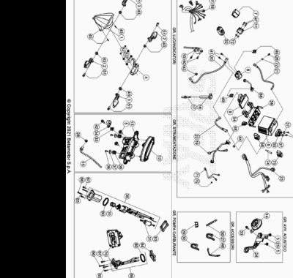

ENDURO_RR_390_4T_MY22
Ref. | Part Number | Description | Part
1 | 031.40.006.00.00 | GRUPO OPTICO | 1
2 | 020.40.061.00.00 | INTERMITENTE ANT SX - POST.DX | 2
3 | 020.40.060.00.00 | INTERMITENTE ANT DX - POST SX | 2
4 | 037.40.063.00.00 | GRUPO OPTICO POSTERIOR | 1
5 | 037.43.028.00.00 | TORNILLO ESPECIAL M6X8 | 4
6 | 031.40.124.00.00 | BATERIA RR4T MY18 | 1
7 | 18.84948.000 | INTERMITENCIA ALP 200/08 | 1
8 | 27.28471.000 | RELE ARRANQUE RR 2T/ 4T | 1
9 | 037.40.073.10.00 | CENTRALITA PROGRAMABLE | 1
10 | 031.40.021.37.00 | BOBINA | 1
11 | 031.40.025.37.00 | REGULADOR DE TENSION | 1
12 | 037.40.005.00.00 | K/M DIGITAL RR 4T | 1
13 | 037.40.001.00.00 | SOPORTE INSTRUMENTO DIGITAL | 1
14 | 007.40.050.00.00 | AVISADOR ACUSTICO SCOOTER | 1
15 | 031.40.166.00.00 | SENSOR RED | 1
16 | 006.10.055.00.00 | PIPA BUJIA | 1
17 | 006.10.050.00.00 | BUJIA M 12 X 1,25 NGK -LKAR8A-9 | 1
18 | 037.40.074.00.00 | INSTALACION SERVICIO ANTERIOR | 1
19 | 037.40.072.80.00 | INSTALACION ELECTRICA PRINCIPAL | 1
20 | 037.40.008.00.00 | INSTALACION ELECTRICA RELE RR 4T | 1
21 | 020.40.002.00.00 | CABLE MASA | 1
22 | 037.40.007.00.00 | INSTALACIO ELEC. RELE | 1
23 | 037.40.009.00.00 | INSTALACION ELECTRICA SERVICIO RR 4T | 1
24 | 037.40.023.00.59 | SOPORTE AVISADOR ACUSTICO | 1
25 | 25.60311.000 | GRAPA TORNILLO M6 ALP 4.0 2008 | 1
26 | 31.38020.000 | TORNILLO 6 x 10 TBEI | 1
27 | 037.40.026.00.00 | ABRAZADERA | 4
28 | 13.17121.000 | TUERCA M8 BASE CILINDRO CH.10 | 1
29 | 25.24443.000 | GUIA CABLE 6/6 RR-4T / RR 125 / RR-T | 1
30 | 15.14264.000 | ABRAZ.PA 6 NY.DENT.NAT.ABNY-B 3,6 X 200 | 1
31 | 031.40.043.82.00 | KIT FILTRO BOMBA GASOLINA EFI | 1
32 | 007.40.088.00.00 | DISPOSITIVO SWITCH MAPA | 1
33 | 11.46501.000 | TORNILLO ENCAJE M6.10 RSCH8 | 1
34 | 25.25182.000 | ABRAZADERA | 1
35 | 037.40.030.00.00 | PIEZA 35 DAR ALTA BETA MOTOR | 1
36 | 31.73000.000 | TORNILLO SPEC. 4.8 TC 8 VOLANTE | 2
37 | 27.34800.000 | ARANDELA TRANCIATA 4.16 | 4
38 | 024.40.039.00.00 | SILENT BLOCK | 2
39 | 037.40.031.82.00 | BOMBA GASOLINA-KIT | 1
40 | 11.49070.000 | TORNILLO 6X20 RS CH8 | 2
41 | 31.30190.000 | TORNILLO ALLEN TCCE 6.8 | 2
42 | 11.46251.000 | TORNILLO 5.12 RS CH8 | 3
43 | 13.12550.000 | TUERCA M6.5 FLAN. | 5
44 | 037.40.059.00.00 | TAPON | 1
45 | 31.23580.000 | TORNILLO 4,8X13_x000D_ | 3
46 | 037.43.043.00.00 | GOMA BATERIA | 1
47 | 11.47015.000 | TORNILLO 6.12 REV3-04 - RR-4T | 2
48 | 25.24441.000 | PASACABLES | 1
49 | 020.40.006.00.00 | FUSIBLE 10 A | 2
50 | 16.34903.000 | GOMA INSTRUMENTOS ALP 200/08 | 2
51 | 11.48025.000 | TORNILLO HEX/C.ARO 6x16 ( RS-T.8 ) | 4
52 | 13.10910.000 | TUERCA M4 AUTOBLOC. | 2
53 | 043.40.015.00.00 | ESPACIADOR | 2
54 | 037.40.087.00.00 | GOMA CENTRALITA | 1
55 | 031.40.017.00.00 | SENSOR | 1
56 | 032.35.049.00.00 | GOMA | 1
57 | 31.23560.000 | TORNILLO ROSCA CHAPA 4,2.25 TMTIC | 2
58 | 031.40.039.00.00 | RELE | 1
59 | 037.40.085.10.00 | SOPORTE CENTRALITA | 1
60 | 031.40.044.82.00 | KIT JUNTAS | 1
61 | 037.40.115.00.00 |  | 1
62 | 037.40.002.00.00 | SONDA RR 4T | 1
63 | 031.43.087.00.00 | PLACA DE CAUCHO VULCANIZADO | 1
64 | 031.43.090.00.00 | SOPORTE | 1
65 | C24.75.002.00.00 | ESPARRAGO M5 L22 | 4
66 | C24.07.013.00.00 | TUERCA SEGURIDAD | 4
67 | 11.46401.000 | TORNILLO 5X20 LLAVE 8rs RR-4T | 4
68 | 037.40.006.00.00 | INSTALACION FUSIBLE RR 4T | 1
69 | 031.40.045.82.00 | KIT REGULADOR | 1
70 | 031.40.049.82.00 | KIT RACORD CARBURANTE | 1
71 | 031.40.078.00.00 | INSTALACION ELECTRICA DIAGNOSTICO | 1
72 | 27.40500.000 | ARANDELA PLANA 6.12.1,6 DIN125 | 3
73 | 037.40.071.00.00 | RELE | 1
74 | 037.40.054.00.00 | RECTIFICADOR | 1
75 | 031.40.074.00.00 | TAPON | 1

ENDURO_RR_390_4T_MY22
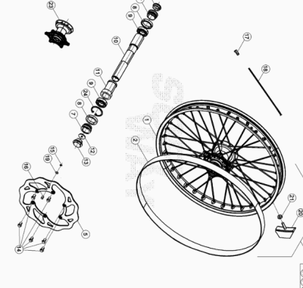

ENDURO_RR_390_4T_MY22
Ref. | Part Number | Description | Part
1 | 031.41.046.00.59 | LLANTA ANTERIOR | 1
2 | 15.38200.000 | SALVACAMARA 750x25-21" RR-4T / RR 125 | 1
5 | 031.41.030.00.00 | #031.41.030.82.00# | 1
6 | 020.41.007.00.00 | TAPON EJE RUEDA ANTERIOR | 1
7 | 031.41.004.00.00 | DISTANCIADOR BUJE DEL. | 2
8 | 10.66000.000 | RETEN 35X47X7 RR-4T | 2
9 | 020.41.003.00.00 | #12.99520.000# | 2
10 | 020.41.005.00.00 | EJE RUEDA DELANTERA | 1
11 | 031.41.015.00.00 | DISTANCIADOR INTERIOR BUJE DELANTERO | 1
12 | 020.41.110.00.00 | TAPON INTERNO RUEDA ANT.RR4TMY11 | 1
13 | 020.41.006.00.00 | TAPON EJE | 1
14 | 031.41.016.00.00 | #031.41.043.00.00# | 6
15 | 28.22660.000 | SEEGER 9E | 1
16 | 021.41.005.00.00 | MAGNETO DIAM. 9 PER SENSORE HALL | 1
17 | 031.41.050.00.00 | TUERCA RADIO ANT. | 36
18 | 031.41.049.00.52 | RADIO ANTERIOR | 36
19 | 27.58080.000 | ARANDELA 9 X 13 X 0.4 ENDURO RR 125 | 1
20 | 036.41.010.00.00 | AGARRE CUBIERTA | 1
21 | 13.17120.000 | TUERCA M8 BASE CILINDRO | 1
22 | 026.41.001.00.59 | RUEDA ANTERIOR | 1
23 | 031.41.014.80.00 | BUJE ANT. C/COJI. Y DIST.INTERNO RR 4T | 1
24 | C01.26.001.00.00 | SEEGER D: 47 X 1,75 | 1

ENDURO_RR_390_4T_MY22
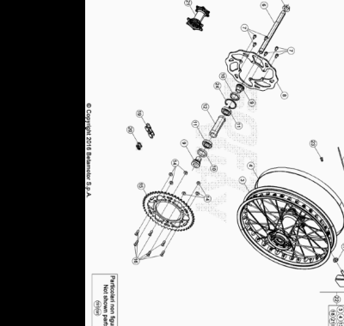

ENDURO_RR_390_4T_MY22
Ref. | Part Number | Description | Part
3 | 031.42.034.00.59 | LLANTA POSTERIOR | 1
4 | 15.36000.000 | SALVACAMARA 575x25-18 | 1
5 | 13.27120.000 | TUERCA ESPECIAL RUEDA POSTERIOR RR-4T | 1
6 | 25.55812.000 | EJE RUEDA POSTERIOR RR-4T | 1
7 | 031.41.016.00.00 | #031.41.043.00.00# | 6
8 | 031.42.030.00.00 | #031.42.030.82.00# | 1
9 | 031.42.002.00.00 | DISTANCIADOR BUJE POST. RR 4T | 2
10 | 10.66000.000 | RETEN 35X47X7 RR-4T | 2
11 | 020.42.004.00.00 | #12.99280.000# | 2
12 | 031.42.005.00.00 | DIST.INTERNO RUEDA POST. RR4T | 1
13 | 031.42.037.00.52 | RADIO POST. | 36
14 | 13.17123.000 | TUERCAS M8 | 6
15 | 026.42.005.00.00 | CORONA Z49 | 1
16 | 31.96827.000 | TORNILLO TGS M8X26 10.9 DACR | 6
17 | 13.17120.000 | TUERCA M8 BASE CILINDRO | 1
18 | 036.42.009.00.00 | AGARRE CUBIERTA | 1
19 | 037.42.001.00.00 | CADENA 5/8 1/4 P.116 | 1
20 | 031.42.008.00.00 | ENGANCHE CADENA 5/8X1/4 | 1
21 | 031.42.014.80.00 | BUJE POSTERIOR C/ COJINETES | 1
22 | 026.42.008.00.59 | RUEDA POSTERIOR | 1
23 | 031.42.051.00.00 | CABECILLA POST. | 36
24 | C01.26.001.00.00 | SEEGER D: 47 X 1,75 | 1
151 | 031.42.028.00.00 | CORONA Z 45 | 1
191 | 037.42.002.00.00 | CADENA 5/8 1/4 P. 114 RR 4T EU | 1

ENDURO_RR_390_4T_MY22
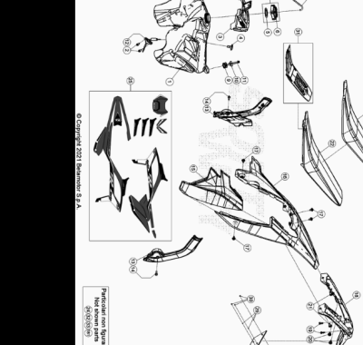

ENDURO_RR_390_4T_MY22
Ref. | Part Number | Description | Part
1 | 037.43.000.00.51 | DEPOSITO GASOLINA BLANCO RR4T | 1
2 | 11.46251.000 | TORNILLO 5.12 RS CH8 | 2
3 | 037.43.006.00.97 | TAPA DEPOSITO | 1
4 | 31.89010.000 | TORNILLO BLOQUEO SILLÍN RR-4T / RR 125 | 1
5 | 031.43.116.00.00 | JUNTA TAPON GASOLINA | 1
6 | 036.43.041.80.00 | TAPON DEPOSITO GASOLINA | 1
7 | 036.43.041.82.00 | TAPON GASOLINA COMPLETO | 1
8 | 020.43.003.00.00 | TUBO TAPON-VALVULA PURGA AIRE | 1
9 | 032.37.013.00.00 | SILENT-BLOCK | 1
10 | 020.43.002.00.00 | DISTANCIADOR DEPOSITO GASOLINA | 1
11 | 11.50300.000 | TORNILLO 6,30 RS CH 8 RR-4T / RR 125 | 1
12 | 037.40.002.00.00 | SONDA RR 4T | 1
13 | 037.43.078.00.59 | PROTECTOR CHASIS | 1
14 | C24.31.046.00.00 | TORNILLO M 5 X 8 8.8 DIN 6921 | 2
15 | 037.43.005.87.97 | PLACA FILTRO | 1
16 | 037.43.007.87.97 | GUARDABARROS POSTERIOR RR | 1
17 | 037.43.028.00.00 | TORNILLO ESPECIAL M6X8 | 4
18 | 037.43.112.00.59 | PORTAMATRICULAS | 1
19 | 31.79960.000 | TORNILLO AUTOROSCANTE M6x15 | 2
20 | 037.43.029.00.00 | TORNILLO ESP. M 6 X 12 | 2
21 | 037.43.030.00.00 | TORNILLO ESPECIAL M 6 X 16 | 2
22 | 037.43.106.00.00 | ASIENTO | 1
23 | 037.43.107.00.00 | FUNDA SILLIN | 1
24 | 037.43.105.82.00 | KIT CONTENEDOR FILTRO | 1
25 | 037.43.108.82.00 | SERIE ADHESIVOS ENDURO RR2T/4T 2022 | 1
26 | 018.43.010.10.59 | SOPORTE MATRICULA | 1
27 | 12.33086.000 | REFLECTOR POSTERIOR RR.4T 7 RR 125 | 1
28 | 31.29860.000 | TORNILLO TTLIC 5.16 CABEZA 10 | 3
29 | 27.36000.000 | ARANDELA PLANA 5.11 | 3
30 | 13.11010.000 | TUERCA M5 AUTOBLOC. | 3
31 | 037.43.084.80.00 | SOPORTE SILLIN | 1
32 | 15.14301.052 | BRIDA FIJACION FRENO POSTERIOR | 1
33 | 31.29827.059 | TORNILLO M5x10 | 1
181 | 037.43.113.80.59 | PORTAMATRICULAS HO | 1

ENDURO_RR_390_4T_MY22
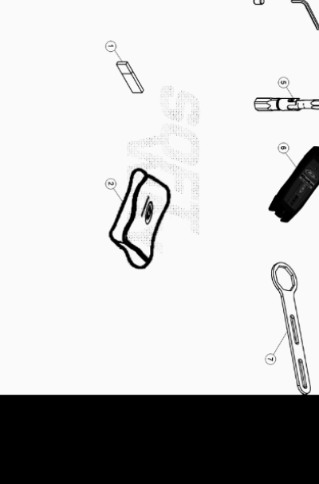

ENDURO_RR_390_4T_MY22
Ref. | Part Number | Description | Part
1 | 037.44.051.83.00 | PEN DRIVE USO Y MANTENIMIENTO RR 4T 2022 | 1
2 | 020.44.202.80.00 | BOLSA HERRAMIENTAS | 1
3 | 020.44.003.00.00 | LLAVE ESPECIAL ALLEN 6 MM | 1
4 | 020.44.004.00.00 | LLAVE ALLEN 8 MM | 1
5 | 037.44.001.00.00 | LLAVE BUJIA RR 4T | 1
6 | 031.44.016.82.00 | KIT DE DIAGNOSIS INYECCION ENDURO 4T | 1
7 | 031.44.034.00.00 | UTILAJE TAPON HORQ. | 1

ENDURO_RR_390_4T_MY22
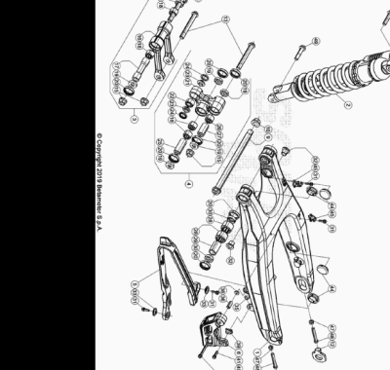

ENDURO_RR_390_4T_MY22
Ref. | Part Number | Description | Part
1 | 037.33.003.00.59 | BASCULANTE RR 2T MY 20 | 1
2 | 037.33.020.80.00 | AMORTIGUADOR RR 4T | 1
3 | 020.33.030.80.00 | BIELETA COMPLETA | 1
4 | 020.33.020.80.00 | TRAPEZIO COMPLETO | 1
5 | 037.33.006.00.00 | PATIN CADENA | 1
6 | 037.33.004.00.00 | GUIACADENA | 1
9 | 037.33.005.50.00 | EJE BASCULANTE | 1
10 | 037.33.008.50.00 | TUERCA | 1
11 | 29.11866.100 | TENSOR CADENA IZQUIERDO RR-4T | 1
12 | 29.11865.100 | TENSOR CADENA DERECHO RR-4T | 1
13 | 11.63992.000 | TORNILLO 12.1,25.96 BIELETA RR-4T | 2
14 | 020.33.032.00.00 | TORNILLO ESPECIAL M 12 | 1
15 | 13.21130.000 | TUERCA 12 RR-4T | 3
16 | 020.33.030.00.00 | BIELETA | 1
17 | 020.33.031.00.00 | DISTANCIADOR | 1
18 | 11.22055.000 | COJINETE 20X26X16 RR-4T | 4
19 | 28.14083.000 | SOPERO BIELETAS RR-4T | 6
20 | 10.64481.000 | JUNTA ACEITE 25X32X7 RR-4T | 10
21 | 020.33.020.00.00 | TRAPECIO RR4T2010 | 1
22 | 16.17310.000 | GABIA 12.24.13 | 1
23 | 11.21920.000 | CASQUILLO TRAPECIO RR-4T | 2
24 | 10.56020.000 | RETEN 16.24.4 | 2
25 | 13.62813.000 | DISTANCIADOR 12X20X50 RR-4T | 1
26 | 11.22061.000 | COJINETE 20x26x30 | 1
27 | 13.62812.000 | DISTANCIADOR 12X20X40 RR-4T | 1
28 | 11.22056.000 | COJINETE 22X28X12 RR-4T | 4
29 | 13.49183.000 | DISTANCIADOR BASCULANTE RR-4T | 2
30 | 28.14081.000 | SOPERO BASCULANTE RR-4T | 4
31 | 11.46251.000 | TORNILLO 5.12 RS CH8 | 4
32 | 020.33.001.00.00 | DISTANCIADOR BASCULANTE RR 4T 2010 | 2
33 | 27.74786.000 | ARANDELA RR-4T | 2
35 | 13.12610.000 | TUERCA AUTOBLOCANTE GUIACADENA ENDURO 4T PS-M6-3 | 1
36 | 13.49191.000 | DISTANCIADOR RR-4T | 1
38 | 13.13020.000 | TUERCA M6 AUTOBLOC. BASSO | 1
39 | 13.48868.000 | DISTANCIADOR RR 4T 2008 | 1
40 | 11.50535.000 | TORNILLO M 6X45 RS CH 8 | 1
41 | 11.49070.000 | TORNILLO 6X20 RS CH8 | 1
44 | 29.10596.136 | TAPON BASCULANTE DIÁMETRO 30 RR-4T | 4
45 | 15.14605.000 | BRIDA FIJACIÓN TUBO FRENO RR-4T | 2
47 | 13.17122.000 | TUERCA M8 ENDURO RR 125 | 2
48 | 11.55909.000 | TORNILLO 8X55 IF CH 10 ZB | 2
49 | 11.62050.000 | TORNILLO 10.45 RR-4T | 2

ENDURO_RR_390_4T_MY22
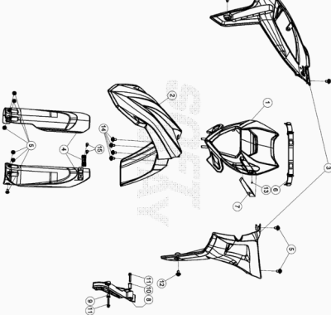

ENDURO_RR_390_4T_MY22
Ref. | Part Number | Description | Part
1 | 037.43.008.00.97 | PORTAFARO | 1
2 | 037.43.009.00.97 | GUARDABARROS ANTERIOR | 1
3 | 037.43.001.00.97 | JUEGO PLACAS RADIADOR | 1
4 | 040.43.006.82.97 | KIT PROTECTORES HORQUILLA | 1
5 | 037.43.028.00.00 | TORNILLO ESPECIAL M6X8 | 9
6 | 037.43.020.00.59 | GOMA PORTAFARO | 2
7 | 037.43.017.00.97 | PASACABLES | 1
8 | 037.43.026.00.59 | PROTECTOR PIÑON | 1
9 | 13.49190.000 | DISTANCIADOR RR-4T / RR 125 | 1
10 | 13.49189.000 | DISTANCIADOR RR-4T/06 | 1
11 | 11.50300.000 | TORNILLO 6,30 RS CH 8 RR-4T / RR 125 | 2
12 | 037.43.030.00.00 | TORNILLO ESPECIAL M 6 X 16 | 2
13 | 31.23580.000 | TORNILLO 4,8X13_x000D_ | 1
14 | 037.43.029.00.00 | TORNILLO ESP. M 6 X 12 | 4
15 | 31.30030.000 | TORNILLO AUTOROSC . 6 X15 | 2

